Assignment 5.
- What is landscape?
- An SAP landscape is the set of SAP systems used by an organization to develop, test, and run SAP applications.
- Each system in the landscape has a specific purpose, such as development, testing, or live business operations.

- What are the different landscapes available in SAP system and explain them?
- DEV (Development)
- Where developers work
- Write ABAP code
- Configure SAP
- QAS / QA (Quality / Testing)
- Used for testing
- Checks if changes work correctly
- Used by testers & functional consultants
- PRD (Production)
- Live system
- Real business data
- Used by actual users (finance, sales, HR)

- Development System (DEV)
- The DEV system is used to develop programs and configure SAP settings. It allows developers to make changes without affecting business users.

- Quality System (QAS)
- The QAS system is used to test all developments and configurations. It ensures changes work correctly before moving to production.

- Production System (PRD)
- The PRD system is the live system used by end users for daily business operations. It contains real business data and must be stable.

- Explain the architecture of SAP? Refer
- *Presentation Layer
- The presentation layer is the user interface of SAP where users interact with the system using SAP GUI or Fiori. It only displays data and sends user requests to the application layer.
*Application Layer
- The application layer processes all business logic and executes user requests. It contains application servers that communicate with the database and manage system workload.

*Database Layer
- The database layer stores all business data of SAP in tables. Users cannot access it directly and all data operations are handled through the application layer.
- 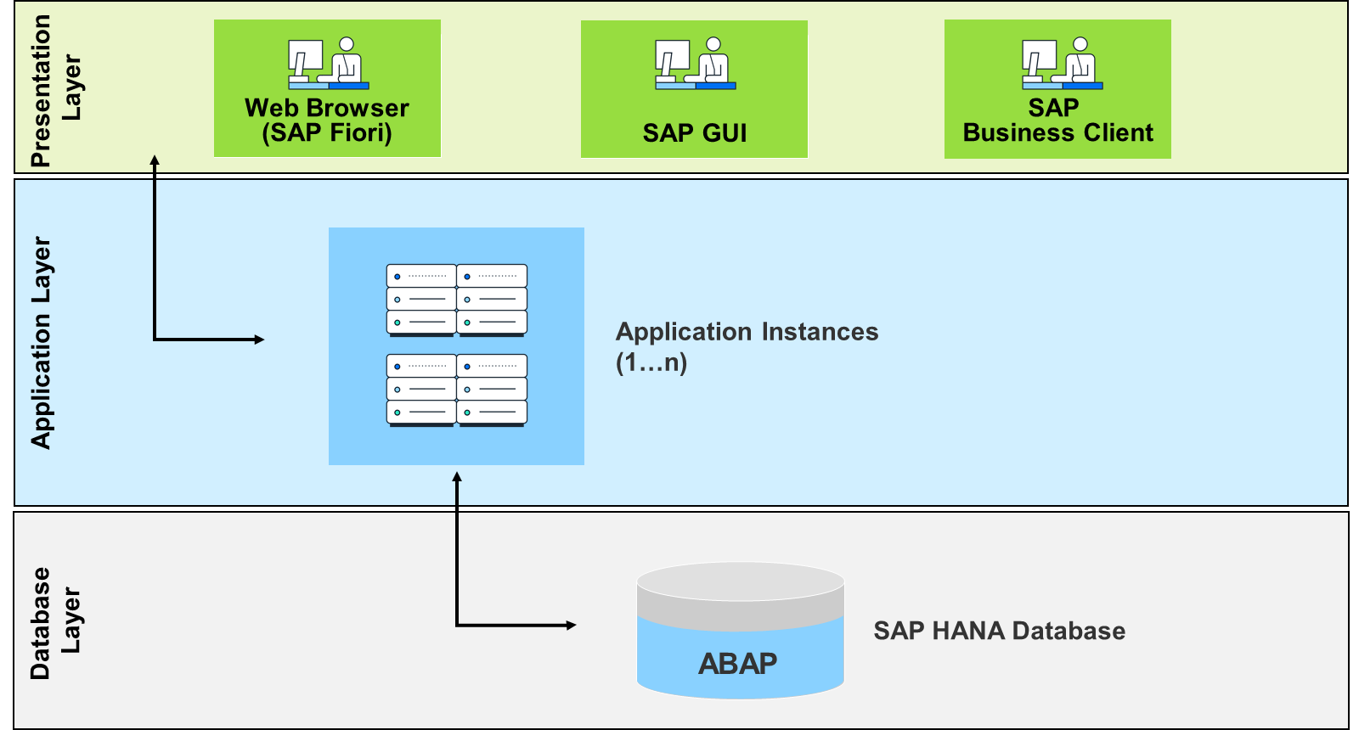

- List out the advantages and disadvantages of R/3 architecture?
- SAP R/3 introduced a three-tier client-server architecture. It was flexible, scalable, and became the foundation for modern SAP systems.
- Advantages of SAP R/3 Architecture:
- Uses three-tier architecture (presentation, application, and database), which improves system performance and scalability.
- Supports multiple users simultaneously, making it suitable for large organizations.
- Provides high data consistency since all users work on a centralized database.
- Platform-independent and can run on different operating systems and databases.
- Easy to upgrade, maintain, and extend compared to older R/1 and R/2 systems.
- Allows load balancing by distributing work across application servers.
- Strong security and authorization mechanisms.

- Disadvantages of SAP R/3 Architecture:
- High implementation cost, including software, hardware, and training.
- Requires skilled consultants and administrators to manage the system.
- Complex system architecture, which can be difficult for beginners to understand.

- Advantages of centralized database?
- Advantages:
- Reduces data redundancy since all data is stored in one central location.
- Ensures data consistency and accuracy across all departments.
- Provides real-time access to updated information.
- Simplifies data management and maintenance.
- Improves data security with centralized control and authorization.
- Makes backup and recovery easier and more reliable.
- Supports better reporting and analytics for decision-making.
- Enables smooth integration between different business functions.

- Data Consistency and Accuracy:
- Improved Security:
- Reduced Data Redundancy:
- Simplified Data Management & Administration
- Cost Efficiency:
- Enhanced Data Sharing & Reporting:

